| No. of Pages | **9** |
| --- | --- |
| No. of Questions | 7 |

**Department of Computer Science and Engineering**

**FINAL EXAMINATION SPRING 2018**

**CSE421/EEE465: Computer Networks**

**Total Marks: 100 Time Allowed: 2 Hours 30 minutes**



* Answer **Any** **Five (5)** questions out of **Seven (7)** questions.
* Figure in bracket [] next to each question indicates marks for that question.



###### Question No. 1

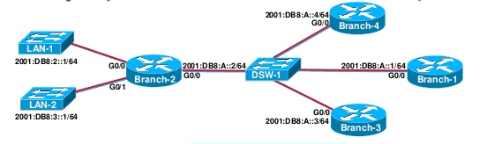

1. Refer to the above **Figure no. 1**, a static route from router Branch-1 to the network 2001:DB8:3::1/64 in Branch-2 must be created. The command is “ip route 2001:DB8:2::1/64 __________”. What should be used in the gap for efficient routing, next hop IP or exit interface and why? [2+3 marks]
2. When and why do we need to change the AD (administrative distance) of a static route to a higher value than 1? [4 marks]
3. For **Figure no. 2&3** below, all routers are running RIP routing protocol. The static route configured in ORL router is not showing in JAX and CHI router, why not? If the route was displayed, then how will it be displayed as static or dynamic? [3+2 marks]

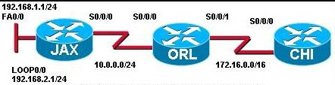







1. The routers below is running RIPv2 shown in **Figure no. 4.** Manually summarize the following networks shown at the RouterA so that it can advertise only one summarized network in its updates instead of the 8 separate networks. Show calculations. What will be the summarized network if automatic summarization was turned on? [4+2 marks]

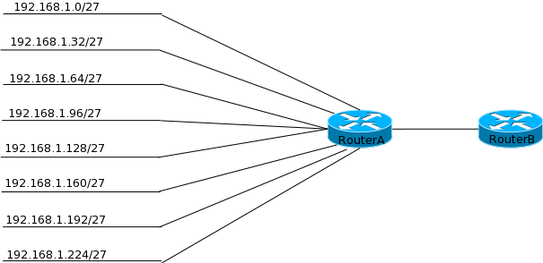

###### Question No. 2

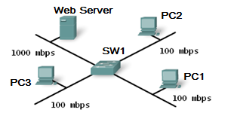

1. Refer to **Figure no. 5** above; there is a lot of traffic flowing from the Web Server to the PCs. What kind of switching method should be chosen here at switch SW1 and why? [2+3 marks]
2. When should we use a router instead of a layer 3 switch? [3 marks]
3. What is the name of the table shown in the **Figure no. 6** below? Explain the term “DYNAMIC”. Why are there two MAC addresses associated with one port? [3+3 marks]

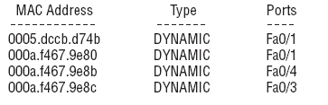

1. Refer to the above output shown in **Figure no.7** below,
2. The violation count is showing “1” but the port status is still up, why?
3. The outsider now turns the switch off and then on again. He connects to fa0/20 port and tries to send harmful data, will he be able to or not? [3+3 marks]

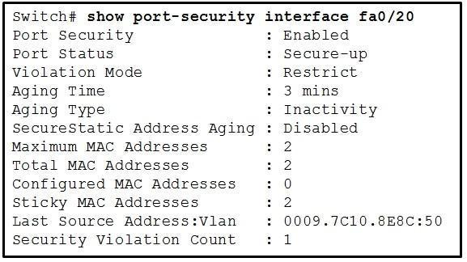

###### Question No. 3

1. What is the difference between default VLAN and management VLAN? [3 marks]
2. What is tagging in a switched network and done by which protocol? Refer to **Figure no.8**; there are 3 VLANs 10, 30 and 150 configured in the switches. Which device/s will perform tagging in the topology below? [2+1+2 marks]

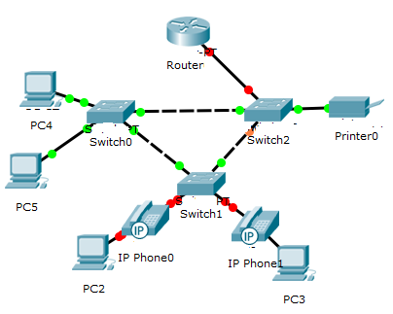

1. Refer to the **Figure no 9 & 10** below. The devices in the network are operational and configured as indicated. However, PC4 is unable to connect with PC1 or PC3. State the causes of this problem and also provide the solution. (At least two problems) [4 marks]







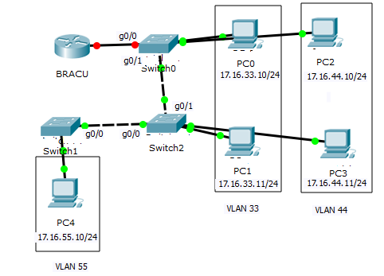





1. Refer to the commands shown in the above **Figure no. 11**, [3+2+3 marks]
   1. Explain what “dot1q” represents. After configuration the interfaces are not coming up, what could be the problem?
   2. The VLAN number and the router sub-interface number do not match, will it be a problem? Explain briefly yes or no.
   3. And when a packet arrives with the destination IP address of 192.168.99.220/27, which sub-interface will the router use to send the packet?

###### Question No. 4

1. Suppose that the data bytes of an original datagram is 2020 bytes which includes 20 bytes of header. The datagram is to be sent from PC1 to PC2. The datagram has to go through the network R1 –R2. The network between R1 and R2 only allows maximum data frames of 500 bytes. The identification number of the first datagram is 222 and the first byte position is 0. Header length is 20 bytes. So fragment the data accordingly using the given table **separately.** [6.5 marks]
2. The **Figure no.12** below represents the partial header of IPv4. What are the purposes of the “Protocol” and the “Header Checksum” fields? [2+2 marks]

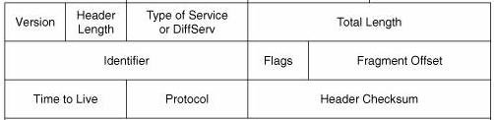



Reply from 127.0.0.0: bytes=32 time<1ms TTL=128

Reply from 127.0.0.0: bytes=32 time<1ms TTL=128

Reply from 127.0.0.0: bytes=32 time<1ms TTL=128

Reply from 127.0.0.0: bytes=32 time<1ms TTL=128



1. The output shown above in **Figure no.13** was received from which application and which protocol? What is its purpose? [2+3 marks]

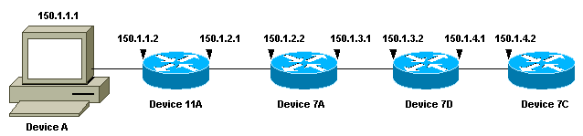

1. In the above **Figure no.14**, if Device A issues a traceroute to the IP address 150.1.4.2. What is the first packet sent by DeviceA to Device 11A and how does Device 11A reply? [2.5+2 marks]

**Question No. 5**

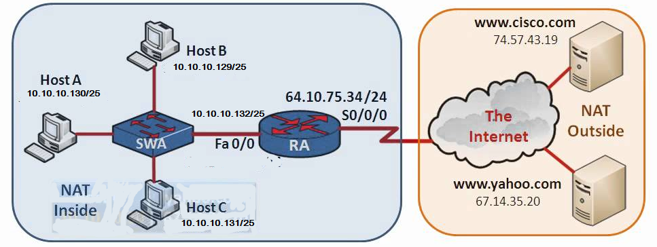 

1. Refer to the **Figure no. 15** above. Write the commands, which are necessary for the router RA to dynamically translate the private network address of the company to a public address pool of first 10 addresses starting from 64.10.75.35/24 with PAT. Do not forget to apply NAT at the interfaces. [6 marks]

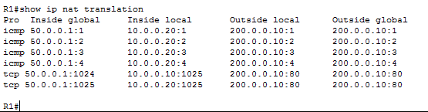



1. Refer to the output shown in **Figure no.16** above. Identify the inside private address being translated to which public address? Also identify the source port number and destination port number. Use the last two lines. Why is the outside local and outside global addresses the same? [2+2 marks]
2. Refer to the topology and output shown in **Figure no.17 & 18** below. HQ router has been configured to act as the DHCP server for the 210.10.10.0/24 and 193.10.10.0/24 networks. [2+2+2 marks]
   1. PC1 and PC2 are unable to go out of their network, why?
   2. HQ router displays error message of address conflicts, why?
   3. PC0 cannot get any IP address via DHCP, why?

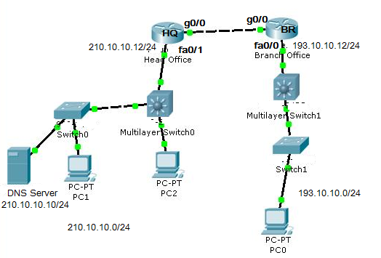





1. Refer to the **Figure no. 19** below. The laptop is enabled with DHCP. So when it is turned on, it sends a DHCP discover packet to get its IP address. What will the router do with this packet when this discover packet reaches router Router0 if DHCP Relay is configured and if DHCP Relay is not configured in router Router0? [2.5+1.5 marks]

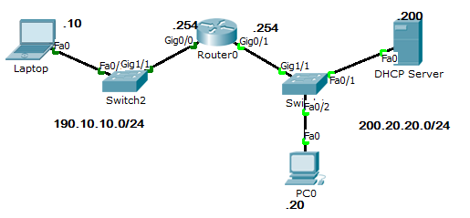

###### Question No. 6

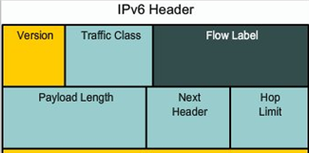



1. The above **Figure no. 20** represents the partial header of IPv6 (Source IP and Destination IP not shown). Explain the purpose of Hop Limit and Flow Label and did IPv4 have a similar header that is a header for the same purpose? [4+1 marks]

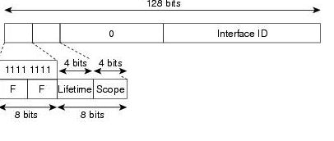

1. Refer to the **Figure no. 21** above, what type of IPv6 address is it? How can this address be used as broadcast address too, if yes how? [2+3 marks]
2. Name the following addresses and state what they are used for. [2+2 marks]
   1. ::/128
   2. FE80::/10
3. Draw the process of Stateless DHCPv6. [6 marks]

###### Question No. 7

1. What happens if ACLs are not placed or implemented at the interfaces of the routers? [2 marks]
2. Referring to the **Figure no. 22** below, write a named standard ACL in Router R2 that will allow all hosts from 173.10.10.0/25 network except PC C1 (IP:173.10.10.10) to access the 193.20.20.0/25 network. Do not forget to place the ACL. How will the placement change if you write the ACL in Router R3? [4+2+2 marks]

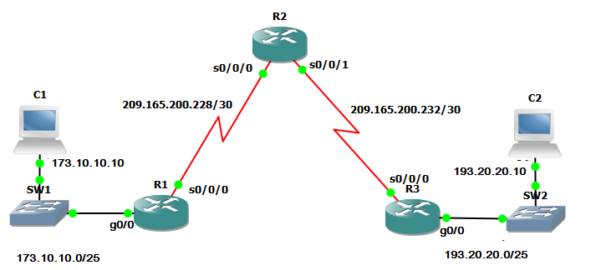

1. Refer to **Figure no. 22**, write a standard ACL that will only allow PC C2 to telnet into the Router R2? [2+2 marks]

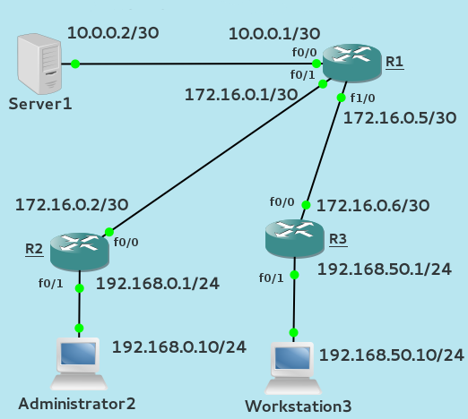

1. Refer to **Figure no. 23**, write a named standard ACL in R1 that will
   1. Not allow Adminstrator2 and Workstation3 to have any access to the Server1. But all other hosts are allowed access to the Server1. Do not forget to place the ACL.
   2. What if you have no access to Router R1, then where would you write the ACLs and place them and in what direction? [3+3 marks]



##### THE END